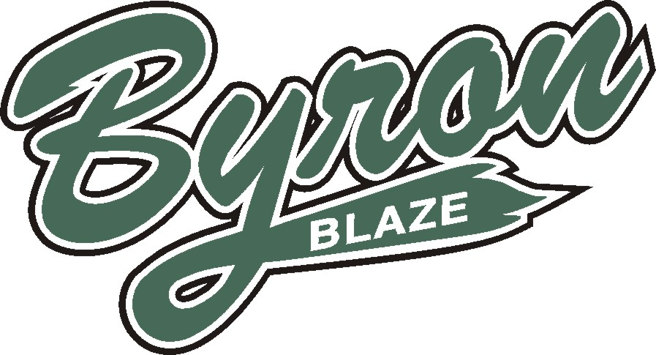

2019 Baseball/Fastball Season

Byron Optimist Minor Baseball Association
PO Box 20026
431 Boler Rd.
London Ontario

Re: Baseball Sponsorship 2019 Season

Dear Community Business Owners and Parents,

The Byron Optimist Minor Baseball Association is seeking sponsorship contributions for the 2019 season. BOMBA provides the opportunity for approximately 500 young persons from our community to play baseball and fastball.

We are seeking your sponsorship of our program to assist us with the costs of providing these programs, so that we can keep our individual registration fees at an affordable amount.

Please check out how we promote our sponsors on our Facebook page @byronoptimistminorbaseball and www.byronbaseball.com.

We gladly accept any donation of funds or you may choose one of our sponsorship options:

1st Base Sponsor $75.00 - Company name listed on Byron Baseball website with contact information where all parents register their child, view schedules and check scores.

2nd Base Sponsor $150.00 – all the above plus company Logo on our website

3rd Base Sponsor $375.00 – all the above plus team sponsorship, 12-14 players on a team, your logo put on the back of each player’s jersey, you pick the age group, first come first serve. Thank you team photo plaque to hang in your business.

Home Run Sponsor $725.00 – all the above plus 2’x8’ banner designed, printed and positioned in bronze level area. Yours to keep at the end of the year. Limited space available. Other higher levels are available just ask!

We greatly appreciate any sponsorship at any level or value.

If you would like more information or discuss your potential sponsorship, please contact me at 226-376-1900 or sponsorship@byronbaseball.ca

Thank you for reviewing this letter.

Sincerely,

Jeff Melody
Sponsorship Coordinator
Byron Optimist Minor Baseball Association

