BYRON OPTIMIST SPORTS COMPLEX
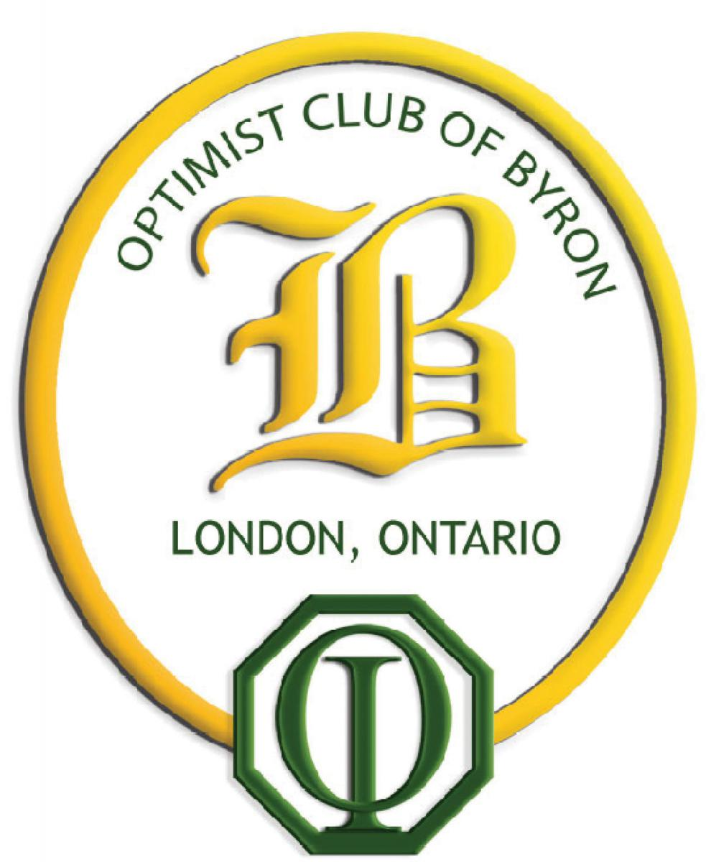
GOLF TOURNAMENT AT FIREROCK
SUNDAY, SEPTEMBER 23, 2018

For almost 40 years, thousands of youth and adults have enjoyed playing and watching sports at the Byron Optimist Sports Complex. This season almost 2 000 boys and girls will be playing in the Byron Optimist soccer and ball programs at the Complex. Thanks to the ongoing financial support of the Byron Optimist Club, our children and many adults have the opportunity to play at one of the finest facilities in Ontario. The Complex is owned by the Optimist Club of Byron and run by a volunteer Board of Directors from Byron.

This is our first golf tournament to help raise funds for the Byron Optimist Sports Complex for its improvements to the sports fields and facilities. We invite you to join us in supporting the Complex so that we can continue to provide the kind of facility we can all enjoy. You can participate by:

- Joining us as a GOLFER for $ 150 which includes an 18-hole round at one of the area’s premier golf courses, lunch, dinner.
- Considering being a HOLE SPONSOR for $ 100, or CART SPONSOR for $ 50.
- Considering being a PRIZE DONOR for our raffles, silent or live auction.
- Considering an outright DONATION to the Byron Optimist Sports Complex which is a registered charity and can issue tax receipts for donations.
- Registering to play or sponsor at: https://form.jotform.com/firerockgolf/byron-optimist-sports-complex-golf-

For further information contact one of our tournament organizers who are all members of the Byron Optimist Sports Complex Committee:

Bob Thibert – 519-641-4126 – bobthibert@yahoo.ca
Gerry Smith – 226-377-4377 – gerrycsmith@rogers.com
Larry Dilling – 519-657-4375 – dillingl@rogers.com

