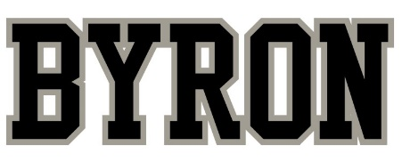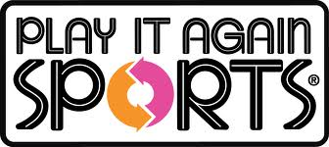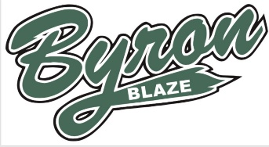

Byron Baseball Weekend
“25% Days”

Sat May 5 and Sun May 6
Just come into the store on May 5 & 6 & let us know you are with Byron Baseball.

YOU Save right now!
15% OFF
all purchases

Byron Baseball receives!
10%
of all purchases made by Byron Baseball families

Also, trade in your used gear and receive a
25% Bonus on Store Credit / Trade-In option
For all quality used sporting goods that we are able to purchase.

*These offers cannot be combined with any other specials. All Consignment items are excluded from this special. Savings on all purchases is for anything in the store not just baseball gear. Trade in bonus applies to all items that we are able to purchase.

We Buy Used Every Day!!
1314 Huron St., London, ON (519) 453-7529 piaslondon@hotmail.com www.playitagainsportslondon.com

